**Name: Anupam Kumar Jha | Roll No.: 21f1004905**

**BDM PROJECT**

**To Increase the Sale and Reduce the Manufacturing Cost of a Firm of Bricks Industry**

* **Executive Summary**:

This is the second document in line with the BDM capstone project. In this project, we have identified two problems of Ramdev Bricks Manufacturers which are to increase the sale and reduce the manufacturing cost of bricks. For this purpose, primary data has been collected with the help of owners. The proof of this process has been given in the section “**Primary Data Collection Procedure**”. The data was put on MS Excel worksheets to start our analysis process. As it was raw data, so first it was cleaned to make it ready for further analysis. After cleaning the data, descriptive analysis was done on the data whose full description is given in the section “**Descriptive Statistics**”. To find the trends and relationships, a graphical analysis was done that helped us find clues and causes of the given problems. Then these findings and results were shown to stakeholders to cross-check our interpretations. After validating our interpretations, I will start working on finding recommendations for these problems with the help of books, the internet and owners. The whole process is explained in the section “**Explanation of Analysis Process”.**

* **Primary Data Collection Procedure:**

The data has been collected with help of owners. As it’s a small business so they don’t store data electronically. They use the old method: keep data in a diary, notebooks etc. And few of the data were collected from the market itself. I am in constant touch with the owners to understand data correctly. The proof of originality is given below in form of photos, videos of the meeting with the owner and a letter from the organization.

* + 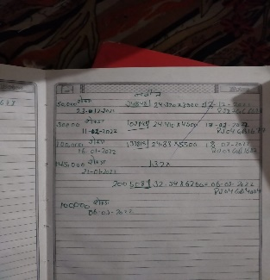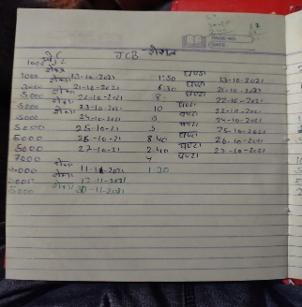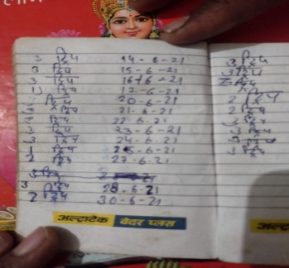Photos:

Coal's Data

Digging Data

Clay Data

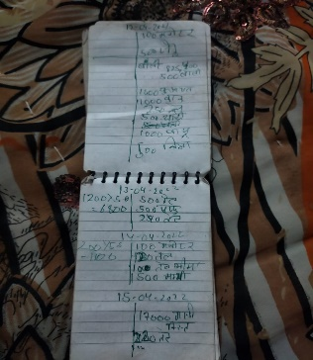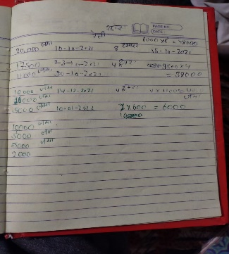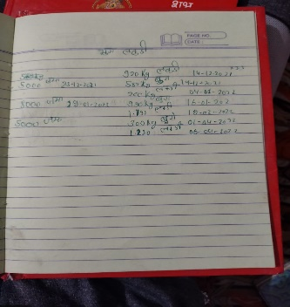

Sales Data

Rally Data

Wood Data

* + Letter from the organization:

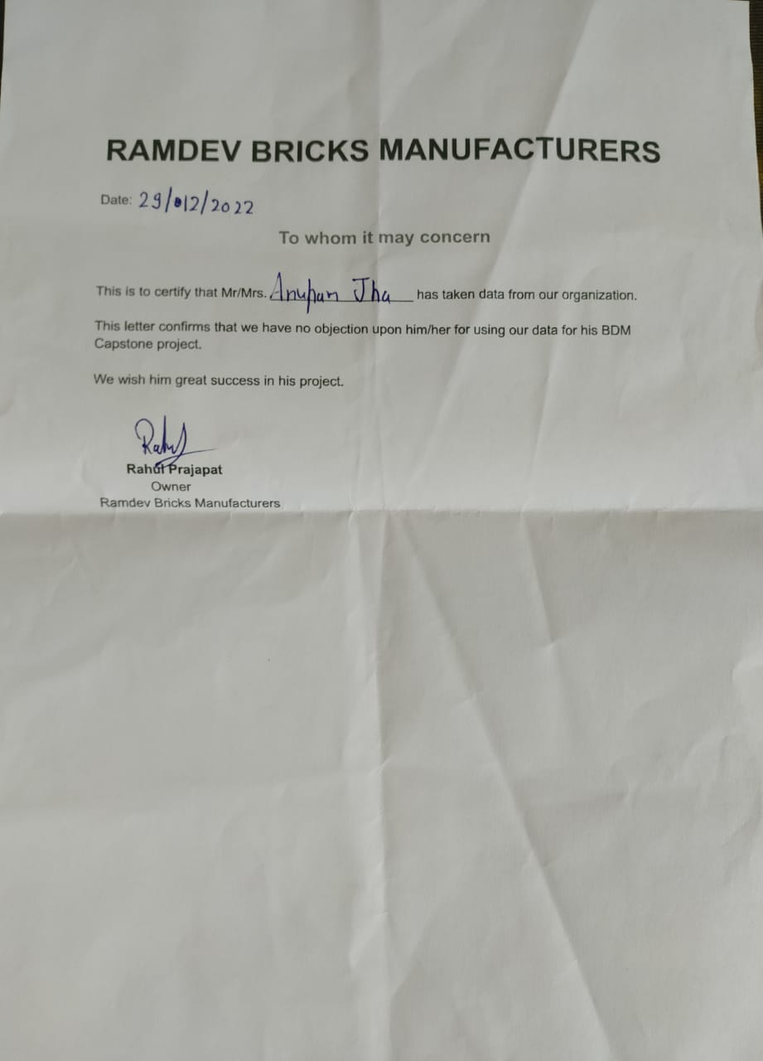

* + Video Link:

<https://drive.google.com/file/d/1pmzJ3hlgraLujEMRol27KrV_a0xdhH-I/view?usp=share_link>

* **Descriptive Statistics**:
  + **Sales Data**:

The daily sales data from 1 Dec. 2021 to 30 Nov. 2022 has been collected. And then the data was cumulated on monthly basis. The descriptive statistics of the data are as follows:

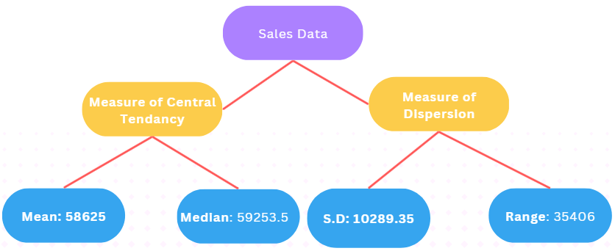

* + - Total sales from Nov.21 to Dec.22: 7,03,500 bricks
    - The mean of data points is 58625 bricks.
    - The median of data is 59253.5 bricks.
    - The standard deviation of the data is 10289.35 bricks.
    - The maximum number of sales happened in the month of Jan. 2022 which is 75455 bricks.
    - The minimum number of sales happened in the month of Nov. 2022 which is 40049 bricks.
    - The 1st and 3rd quartiles are 55207.5 bricks and 63706.5 bricks respectively.
  + **Manufacturing Data:** 
    - **Rally’s Data:**

There were 2 kinds of the rally were bought because of the different uses of respective rallies.

* + - * 9 dumpers and 4 tractors (i.e., around 275 tonnes) were bought of 1st kind which is cheaper that is costed ₹58400.
      * 4 dumpers (i.e., 120 tonnes) were bought of 2nd kind which is costlier and that is costed ₹38000.
    - **Wood’s Data**:

To produce heat wood is required and its descriptive statistics are given below:

* + - * The wood was bought in 6 phases (i.e., on 6 different dates). And the total quantity was 5420 Kg.
      * The incurred cost was ₹18970.00
    - **Digging Data**:
      * The no. of hours of digging happened: 69 hours(approx.)
      * Cost of digging: ₹1000/hour
      * The total cost of digging: ₹68,833.33
    - **Clay’s Data**:

There were three vendors from whom the clay was purchased.

* + - * Vendor1:

Total No. of trips: 148(888 tonnes.)

Cost per trip: ₹1100/trip

Total cost: ₹1,62,800

* + - * Vendor2:

Total No. of trips: 158(948 tonnes.)

Cost per trip: ₹675/trip

Total cost: ₹1,06,650

* + - * Vendor3:

Total No. of trips: 79(474 tonnes.)

Cost per trip: ₹650/trip

Total cost: ₹51,350

* + - **Coal’s Data**:

The coal is used to produce heat which is given to bricks after making. And total cost of coal consists of two costs: 1. Price of coal 2. Transportation cost. And descriptive statistics of coal are as follows:

* + - * Data without including transportation cost:

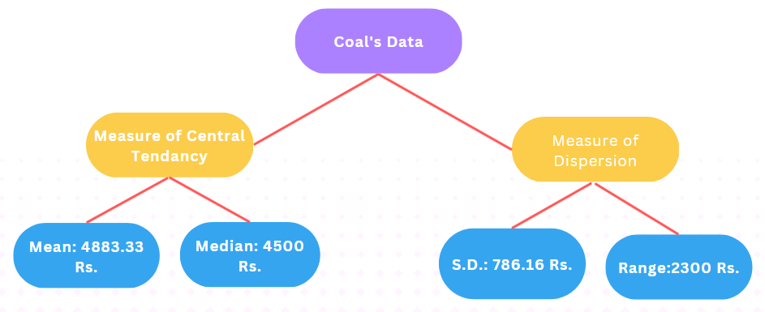

* + - * + The mean of data points is ₹4883.33/tonne.
        + The median of data is ₹4500.00/tonne.
        + The standard deviation of data is ₹786.16/tonne.
        + The maximum price of coal was ₹6200/tonne on 06 Mar. 22.
        + The minimum price of coal was ₹3900/tonne on 12 Dec. 22.
        + The 1st and 3rd quartiles of data are ₹4350/tonne and ₹5250/tonne.
      * Transportation Cost:

There were 4 different vendors from whom the coal was bought and their transport cost varies as follow:

*Vendor1*: ₹1300/tonne

*Vendor2*: ₹1300/tonne

*Vendor3*: ₹1400/tonne

*Vendor4*: ₹1280/tonne

* + - * + The total quantity of coal was bought: 182.82 tonnes.
        + The total cost of coal including Transportation cost: ₹11,31,738.40
    - **Other Cost**:
      * Labour wage:

Making cost: ₹0.75/brick

Total making cost: ₹5,27,625

Wage to put bricks on kiln: ₹0.43/brick

The total wage for putting bricks on the kiln: ₹3,01,500

Total wage: ₹8,29,125

* + - * Electricity used to extract water:

The volume of water extracted: 7,03,500 L

Total units of electricity used: 895.79 units

Cost of electricity: ₹7.1/unit

Total electricity cost: ₹6360.11

* + - * Cleaning expense: ₹30,000 (For 6 months)
      * Transport Cost (For loading bricks from the making area to the kiln area):
        + Driver’s salary: 1,20,000/annum
        + Diesel’s expense:

Price for loading one brick: ₹0.02

Total cost: ₹14,070

* + - * Bricks Loading Cost:

Cost for loading: 0.10/brick

Total Cost: ₹70,350

* + - * Land Lease Cost: ₹40,000/annum
* **Detailed Explanation of Analysis Process/Method**:
  + **Book-Keeping To Excel:**

The data that was collected from the firm was completely raw data and stored in books and diaries. So, the first job was to put it on excel sheets with identifying appropriate variables of the data. This process was the longest as I needed to put the data in excel manually. And it took around 2-3 days.

* + **Data Cleaning:**

After putting the data onto excel sheets, it needed to be cleaned for further analysis.

* + - In sales data, from July 22 to Nov.22 the values were missing. And the missing values were imputed with the mean of daily sales data.
    - In rally data the quantity was measured in two different units: Dumper and tractors and there were two kinds of rallies. So I needed to understand the units in a particular context and put them on a sheet according to that. And also separated the data according to types of the rally.
    - Wood & Digging data was very straightforward, we got all the quantities that were purchased and the number of hours digging was done and their respective cost. So I just put them straight on the sheets.
    - The coal data involved two costs: transportation cost and coal price. So we needed to extract the same from the raw data of coal. There were also different vendors, so that information is also extracted.
    - Clay is a very important raw material in the manufacturing of bricks. And there were three vendors from whom the firm bought clay at different prices so this information needed to be extracted from raw data.
    - The other cost like different labour wages, water expenses, electricity, transportation cost, loading cost, lease cost and cleaning costs were very difficult to extract but with the help of the owner we also got these data and we cleaned them appropriately.
  + **Getting Descriptive Statistics**:

To know about the data set we needed to find metadata and descriptive statistics to get a starting point to understand the problems of business, their impact on business, the causes of the problems, their possible solution and the overall impact of that solution on business. To get descriptive statistics about our data set we used MS Excel. The detailed descriptive statistics of the data are given in the “**Descriptive Statistics**” section. The kind of descriptive statistics I have used are given below:

* + - *Measure of Central Tendency*: The measure of central tendency gives an idea of what a typical value data set can take. Ex: Mean, Mode, Median etc.
    - *Measure of Dispersion*: The measure of dispersion gives an idea about the spread of the data set. Ex: Standard Deviation, Variance, Range etc.
    - *Summary of Data-set*: The minimum, maximum and quartile values give us the overall summary of the data set.
  + **Listen to Data**:

As we know data speaks a lot but we need to listen carefully to get meaning out of that. So then I tried to understand what data is trying to tell us. The details of what data is trying to tell are given in the section “**Findings and Results**”. And to understand it we needed a form of communication and the following medium of communication I have used:

* + - *Line-Chart*: Line-Chart is a very useful chart to give the trend in a time-series data set.
    - *Pie-Chart*: Pie-Chart gives the percentage of contribution of different components as a whole.
    - *Bar-Chart*: The Bar-Chart is used to compare things.
  + **Interpretation of Results and Findings**:

After getting results and findings from the data set, now it was time to interpret these findings to find the cause and clues of problems which we are trying to solve. And below are steps that were taken to achieve this goal:

* + - I tried to interpret the data with the knowledge and learning that has been acquired in the Business Data Management course(ex.: How to read a graph).
    - After applying the knowledge of the industry and market situation of different raw-material that are being used in this industry I came up with different reasons behind the particular nature of the data set.
    - Now, these interpretations were cross-checked with the help of the owner and the internet.
  + **Finding Solutions**:

After reaching out to the cause of the problems, Now I tried to find the recommendations for that problems, their impact on the problem and the overall impact on the business itself. For finding the recommendations, we took the help of owners, articles and the internet.

* **Findings and Results**:

Below are some of the findings and results after analysing our data set:

* + Sales Data:
    - There is no apparent trend in the graph.
    - However, we can see that from June-22 to Sep-22 there is a constant sale.
    - And from Dec-21 to May-22 there is much fluctuation in the sale.
    - Then there is a rise from Sep-22 to Oct-22 but then a sudden drop in Nov-22.
    - The minimum sale was in the month of Nov 22 and the maximum sale was in the month of Jan 22.
  + Manufacturing Cost Data:

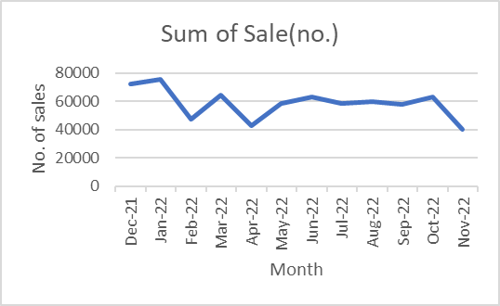

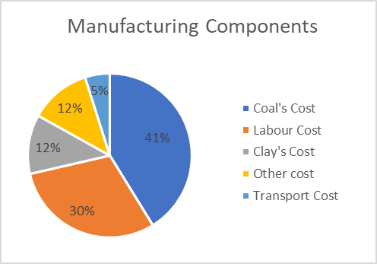

* + - In this pie chart, we can see all the components of manufacturing costs.
    - Coal cost takes 41% part of the total cost which is huge.
    - The labour cost take 30% part of the total cost. That means around 71% of total manufacturing cost incurred due to two things: Coal and Labour.
    - The clay and transportation cost is 12% and 5% respectively.
    - The other cost, which is constituted of Rally, Wood, Electricity, Cleaning, Loading, Land Lease, and Digging Cost, is 12%.
  + Coal Data:
    - 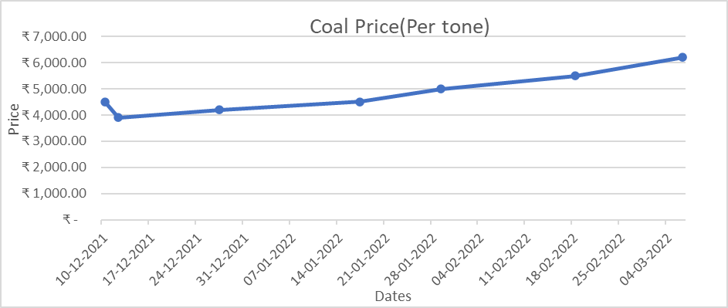In this graph, we see an upward trend.
    - The price of coals was being constantly rising from Dec.21 to Mar.22 except for one drop from 10 Dec. 21 to 12 Dec.21.
    - The minimum price of coal was on 12 Dec.21 and the maximum price of coal was on 06 Mar. 22.